eHealth Exchange Testing Workgroup Meeting |  |  |  |  | Agenda: |  | Minutes: | X
Facilitator: | Didi Davis |  | Date: | 2015/11/10
Note taker: | Matt Blackmon |  | Time: | 3-4:00PM (EDT)
Co-Chairs
Bouhaddou, Ph.D., Omar |  | X | Southerland, Tone |  |  |  |  | X
Attendees
Bannister, Larry |  |  | Leftwich M.D., Russ
Baus, John |  |  | Lyle, Jay |  |  |  |  | X
Blackmon, Matt |  | X | Mangus, Chris
Berkley, Patty |  |  | McCaffrey, Andrew
Botts, Ph.D., Nathan |  |  | Nadella, Srikanth
Clark, Darren |  |  | Odom, Kati |  |  |  |  | X
Cole, George |  | X | Prahl, Marty |  |  |  |  | X
Cook, Ruth |  | X | Roberts, John
Davis, Didi |  | X | Rodrigues, Deepthi
D’Amore, John |  |  | Schramm, David
Donnelly, John |  | X | Seaver Leale, Amy
Heflin, Eric |  |  | Seitz, David
Hossain, Ummey |  |  | Soat, Elaine
Hudson, Gretchen |  |  | Sterling, Leigh
Huynh, Sovann |  | X | Stewart, Ryan
Hyland, Mario |  | X | Swall, Marie |  |  |  |  | X
John, Virginia |  | X | Tyburksi, Michael
Joseph, Kevin |  |  | Weaver, Melissa |  |  |  |  | X
Kopecky, Mike
Lamy, Joe |  | X

Meeting Notes on Published Agenda
- Welcome & Attendance (Omar, Tone, Didi)
- Tone led approval of 11/03/2015 Minutes (M: Melissa Weaver/S: Maris Swall)
- Didi noted some updates to the wiki including the addition of a page (Draft Documentation for Comment) that centrally collects the links to draft documentation for comment (C-CDA_Test_Cases Word Document and CCD_C-CDA_MU_eHEX_Content_Checklist).
Didi also gave a brief over of the updated Exchange Testing WG Content Testing Development Spreadsheet (version 14) related to the “Implementation FAQ” tab. The recommendation was to discuss one future calls one or two of these items as time allows.
- Marie Swall from the VA presented an example of a C-CDA validation from the perspective of the VA. Her presentation is available here.
- Some discussion occurred with reference to the TTT and SITE tools with respect to updates and negative testing.
- Didi discussed homework assignments due before next meeting:
  - Continue review of provided documents
  - Gather and submit de-identified content samples for use in Test Tool Evaluation. Didi requested that the samples submitted implement the test data as identified for Transition of care (http://healthit.gov/policy-researchers-implementers/2014-edition-final-test-method) specifically:

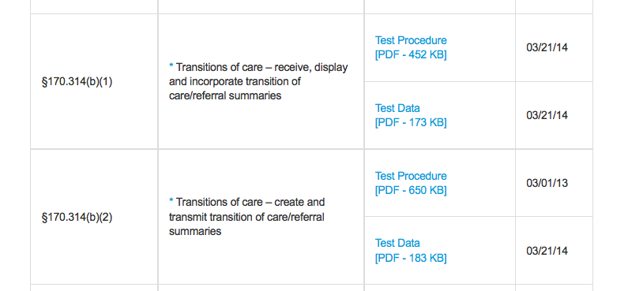

- The next regularly scheduled call of the Testing Workgroup will occur on Tuesday, November 17, 2015 at 3 p.m. (EST). The recording of the meeting is available.

